curEditor Design Requirements
The purpose of the editor is to take PDF files provided by a client and overlay text, signatures and notary stamp images onto the PDF to generate a new PDF. Then attach the notary’s digital certificate (from Identrust) onto the completed PDF files(s). it should be able to handle up to 50 PDF files in a session.
The editor will link with other parts of the overall application to collect inputs and handle the output of the file
Contents
Inputs for the editor 2
Prior to Session Start 3
Tagging 4
Hotkeys 4
Active User . Switching Users 5
Session Start 6
Video Conferencing 8
Chat Feature 8
Verifying Identification 8
Conducting the Meeting 9
Collaborative Viewing 9
Synchronization of Screens 9
The Notary Seal 10
Completing a Document 11
The New PDF 11
The Digital Certificate 11
Uploading Documents During Session 11
Change Signature 11
The Notary Log 12
The Audit Trail 12
The Video 12

Inputs for the editor
Inputs required by the editor:
- PDF Files (up to 50 – usually no more that 10)
- Signers names and email addresses – up to 8
  - Image file for signature
  - Image file for initials
  - Copy of Identification document (driver’s license, passport, etc.)
  - Signer’s digital signing certificate (private CA, no password)
  - Address of signer (for the notary log)
- Observer names and email addresses
- Assigned Notary
  - Notary Name
  - Signature image
  - Initials Image
  - Seal or Stamp Image
  - Notary Commission Number
  - Notary Expiration Date
  - Notary Disclosure (text – 250 characters)
  - Notary State
  - Notary Certificate (PFX File)
  - Notary Certificate password
  - Notary Log File Name
- Video Session ID (we had been using Whereby.com)

Prior to Session Start

Prior to beginning the session, the signers are sent an email with the link to the video session and the schedule start time. They are also prompted to complete the ID verification and, if required, the knowledge-based authentication (KBA). Finally, they are prompted to create the signatures and initials, which are stored in a TRANSPARENT gif file.

The notary is assigned by the system prior to the start of the session, as well. They will be registered, and all of their required info will already be in the database.

The video session will be created when the initial order is processed, and the video links will be sent to all parties. That video session ID will be sent with the invitation emails.

The documents to be signed are uploaded either by the signer or by the person placing the order. They must be in PDF format. We may add a document converter at a later time.

The signers must have their ID verification done through the automated system and approved before they are allowed to join a session. When the session starts, ID is already complete.

Tagging

Tagging is the process of preparing the documents for the notary session. This is done either by the notary or by an administrator. The process looks the same for both. This is where the preparer marks where information needs to be added in the notary session.

Tagging is typically done in a separate “tagging session” prior to the meeting start time. The docs are fully prepped before meeting with the signers.

Tagging can also be done DURING the notary session. If there is information that needs to be completed that was not pre-tagged, the notary can add tags while in the session.

Tags are specific to each user and color coded. The tags indicate what information in required or what will happen when the tag is clicked.

Here are the types of tags

For Signers
A - Name
S – Signature I – Initials

For Notaries
A - Name
N - Commission Number
X - Commission Expiration Date O – Disclosure line
S – Signature E – Seal
W – Whiteout (creates a box that will cover any of the original PDF but sit below any tags that have been placed)

Universal
These tags are not assigned to any specific user. Any user can select these tags and complete the operation
T – Text D - Date

Hotkeys
Hot keys are keyboard shortcuts that allow the notary to quickly place tags or information the
document during either a tagging session or a notary session. The letters next to the tags above are the specific hotkeys for those elements

Active User . Switching Users
To place a tag for a particular user or for the notary, that users must be made active. The tag color will correspond to the active user. To switch between users, the number keys and apostrophe will be used.
“`” - Notary
- – Primary Signer
- – Second Signer Etc.
This allows the notary to switch quickly from one participant to another using just the left hand on the keyboard.
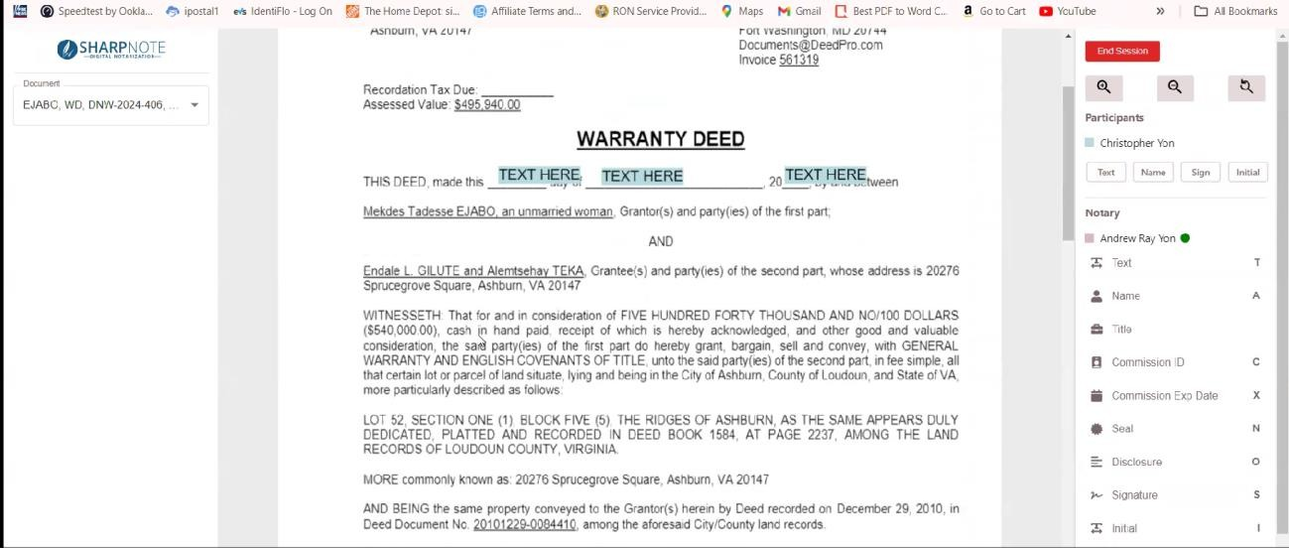
This screen shot shows a tagging session with a few tags in place. There is no video on this screen because this is typically done prior to starting the notary session.

Session Start

When signers click the link, they are allowed to test their video connection and are held in a waiting area.

When the notary starts the session, he will see who is in the waiting area and will permit them to join.

When the signer’s join, their video will appear in the upper-left corner of the screen – one on top of the other.

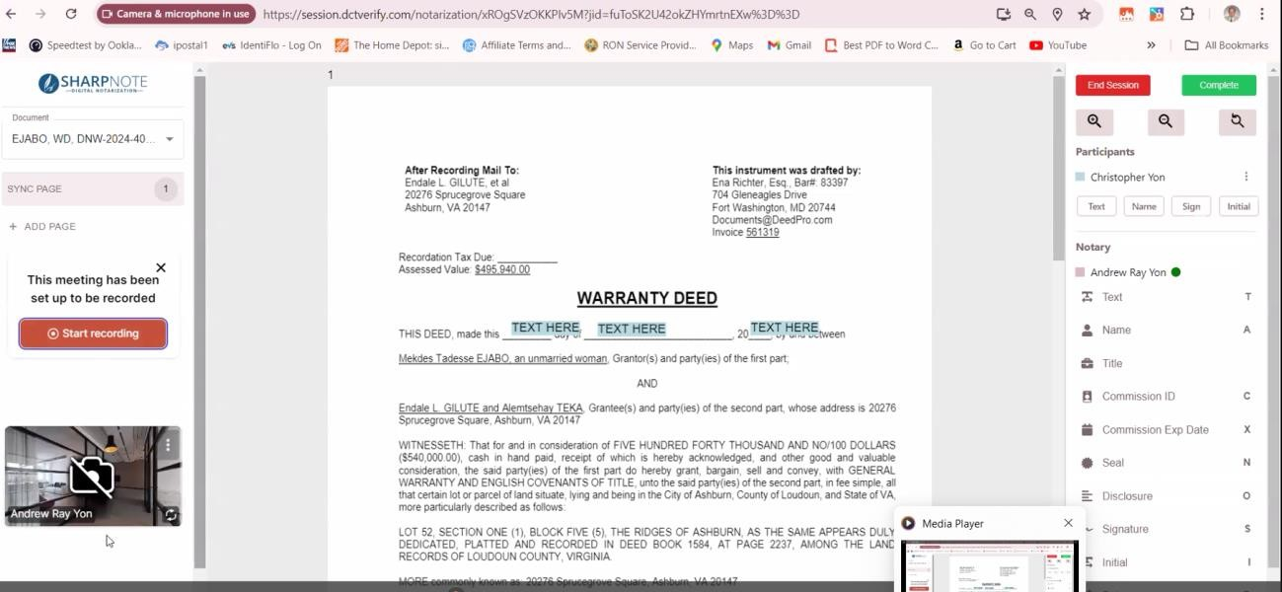
The right side of the screen will have the menu.

Video Conferencing
Because this is an online notarization, the notary and the signers must be able to see and communicate with each other. To facilitate this, we currently have a Whereby.com, but I am open to other platforms if they are easier or more efficient.
Prior to starting the session, while in the waiting room, the signers will be able to test their audio / video capabilities.
Whereby provides a video storage service. We can either use that or set up video storage on our own server. I’m open to whatever is most cost-effective and easy to implement.

Chat Feature
This can either be part of the video API – as it is with whereby – or a separate function within the editor. I’m open to either implementation. There are customization advantages having a separate function, but that can be added later.
Chat is typically used when a signer is having difficulty getting his audio and video to work. Other than that, use is pretty limited.

Verifying Identification

Although the ID verification is done prior to the meeting, the notary must still check the ID in
session and approve it. This is done with a Popup box that allows the notary to see the ID that was uploaded prior to the session and approve or reject it.
If rejected, the signer will receive an email prompting them to redo the ID verification. The session cannot continue until the notary approves the ID.
This must be done for every signer prior the meeting being completed.

Conducting the Meeting

The notary conducts the meeting, provides instructions and witnesses the signers completing each tag in the session.
The notary will also complete his own signatures and seals and any other information requires.
Elements are “overlaid” on the PDF and will be integrated into the final PDF upon completion of the editing session.
Notary can add new tags or delete tags in the session, as needed.

The signers can do NOTHING without a tag. They have no ability to add text or signatures unless the notary places a tag first. This ensures that the notary is in control of the session and knows what is going on at all times.

Collaborative Viewing
Each participant has their own view of the document(s). They can scroll independently and are not reliant on the notary to move a page.
Actions taken are automatically updated on all other participant screen when an image is place, or a text line is COMPLETED. (if you try to sync every letter, server bandwidth will be a problem)

Synchronization of Screens
The notary has the ability to place all users on the same page with a single click on the left menu. This is necessary because signers may be reading ahead and the notary will no know which page they are viewing. Synchronization places everyone on the same document in the same location.

The Notary Seal
When the notary places a seal, he must indicate the type of notarization being done and the signer it pertains to. This information is not written on the document or the seal, but must be stored in the database for the notary log.
A popup box will appear that shows two input selector:
A drop-down menu will allow the notary to choose the type of notarization
- JURAT
- Acknowledgment
- Copy Certification
The list of possible notarization types is part of the notary’s profile. Notaries in
different states may have a different list. The drop-down corresponds to the state laws where they are commissioned.
A checkbox list to choose the signers that this notarization applies to.

For EACH SIGNER, that is selected, an entry will be made in the temporary notary log database containing the type of notarization and all the signer’s information.
Once the session is complete, all of the entries from the temp database will be stored in the notary’s permanent log file.
The audit trail temporary log is also updated with just the Notarization type, page number, and a time/date stamp

Completing a Document

A document cannot be completed until all tags on that document have been used. If they are any open tags, the notary must either delete them or have the appropriate user complete them.

The New PDF
When a document is completed, the notary will select “COMPLETE DOCUMENT” from the menu. This will lock the file from further editing. It will also merge all of the elements from tags back into the original document and produce a new PDF file.
The new PDF file will have the same name with “-complete” appended to it.

The Digital Certificate
Once all documents are completed and the session is done, the notary’s digital certificate will be affixed to the PDF, rendering it tamper-evident.

Uploading Documents During Session

Occasionally, documents get changed during a session. Either the company changes the
document or a new required document is added. To facilitate this, there needs to be an “upload” document function in the signing session. This will allow either the notary or the signer to add a new document to the session without ending and restarting the session.

Change Signature
In some use cases, there are specific requirement for how a signature must appear on a document.
The signer may be required to include a title in the signature or sign with a middle initial in some locations.
Therefore, we must have way for the signer to re-create their signature while in the session. The new signature will not affect where the signature has already been completed, but will affect all new applications of that signers signatures moving forward.
It is also possible that multiple signatures – more than two – may be required for the same person. Changing the signature always changes “future” signatures but not existing signatures for that user.

The Notary Log

The notary is required to maintain a log of all notary sessions that have been completed. It contains an entry for SEAL that is placed on every document. It documents whenever a notarization is done and must be maintained indefinitely.
A separate function will allow the notary to edit the log when not in a session. While in the session, the notary log must be updated before the session ends.
The most logical what to handle this is to store all of the notary log entries in a temporary database and then append them to the notary log file when the session is completed. During the session, the notary may place a seal, make a mistake and delete or change it. Only the final version will be in the log.

The Audit Trail
An audit trail is created and stored as a PDF for each session. It contains the log of every signature and seal placed, where it was placed, by who, and when. It is retained for 10 years with the video.

The Video
The video of the session must be retained for 10 years. It should be accessible from the portal for the first six months, then it can be moved to an off-line storage medium, which is likely more cost- effective.

